Product Inventory Management System

Thunder Client API Testing Results
This section demonstrates the testing of REST APIs using Thunder Client in VS Code. The following screenshots show successful API execution and MongoDB database updates.

1. Create Product (POST)
API Endpoint: http://localhost:5000/api/v1/products
Method: POST
Status: 201 Created
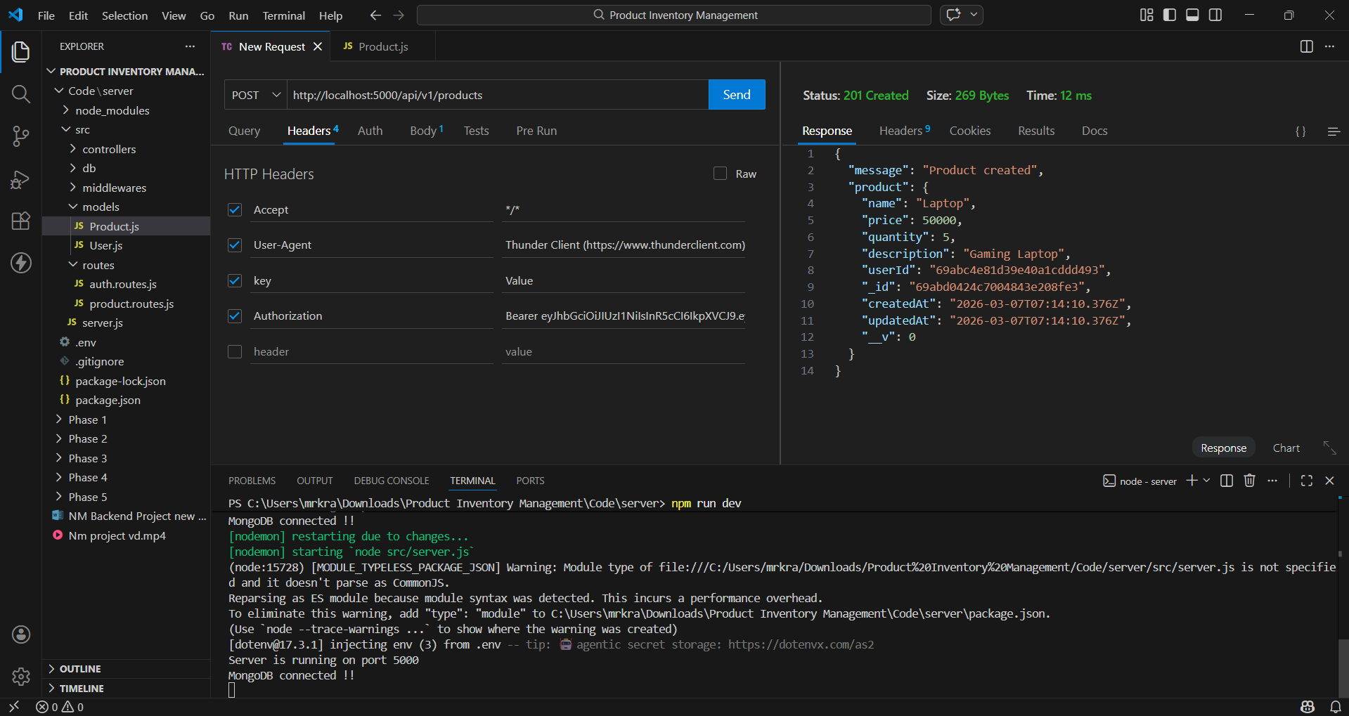

2. Update Product (PUT)
API Endpoint: http://localhost:5000/api/v1/products/{id}
Method: PUT
Status: 200 OK
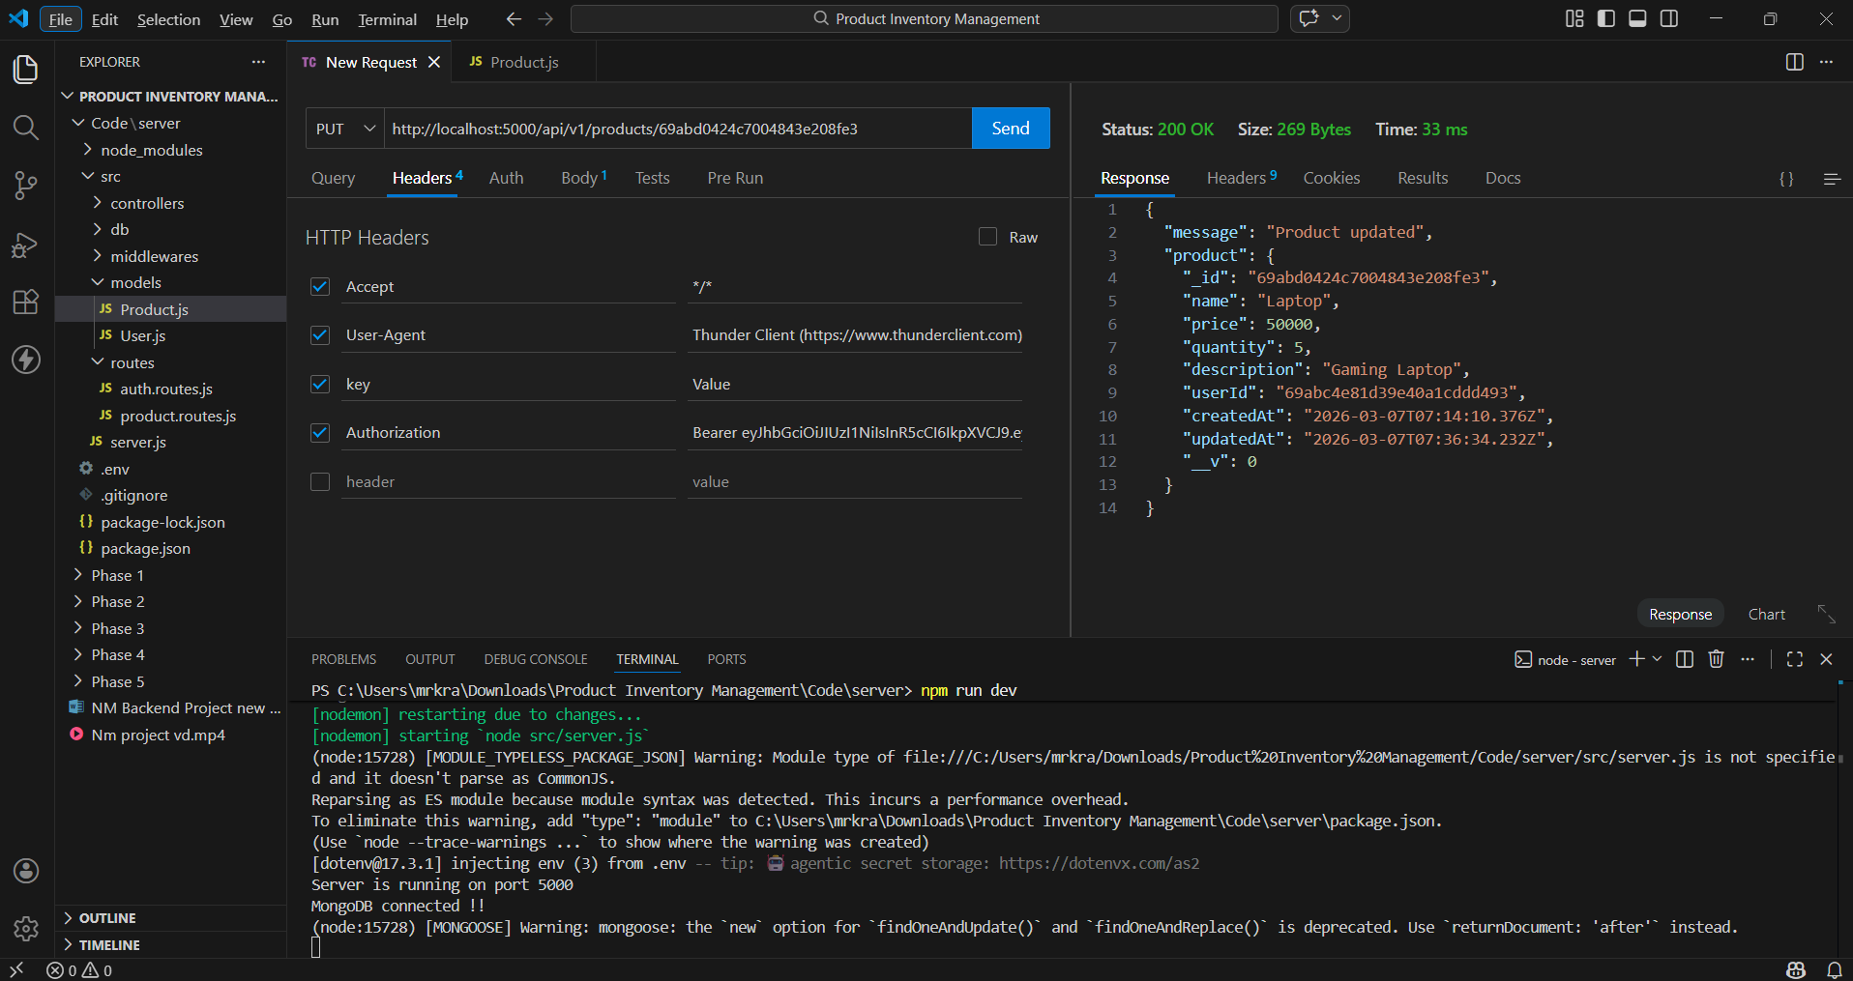

3. Delete Product (DELETE)
API Endpoint: http://localhost:5000/api/v1/products/{id}
Method: DELETE
Status: 200 OK
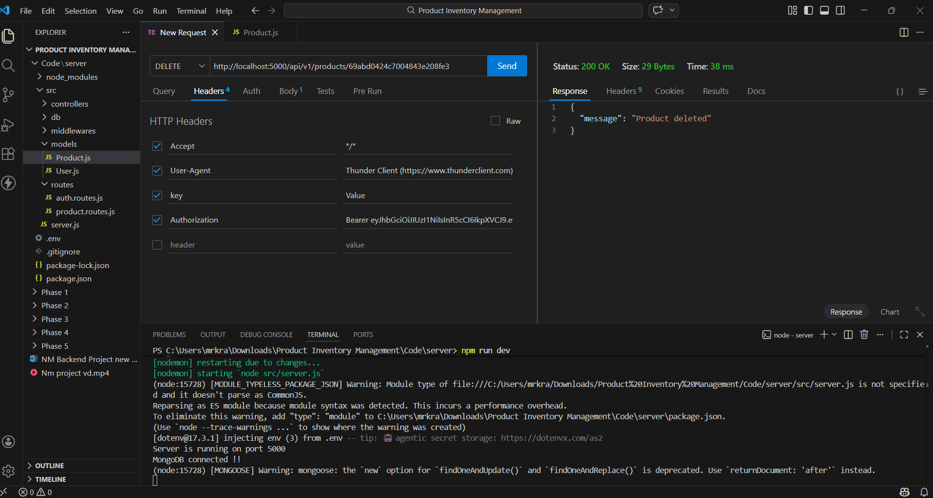

4. MongoDB Database – Products Collection
The following screenshot shows the stored product data in MongoDB Compass after performing API operations.
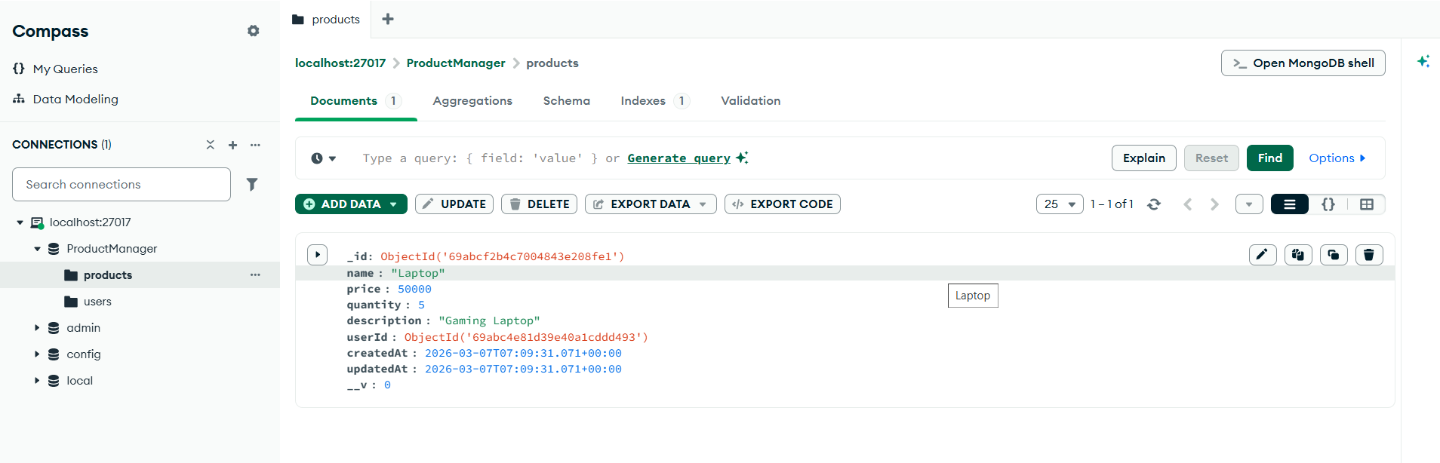

5. MongoDB Database – Users Collection
This screenshot displays the registered user stored in the MongoDB users collection.
